Scanning Family Photos Can Reveal Rare Genetic Disorders
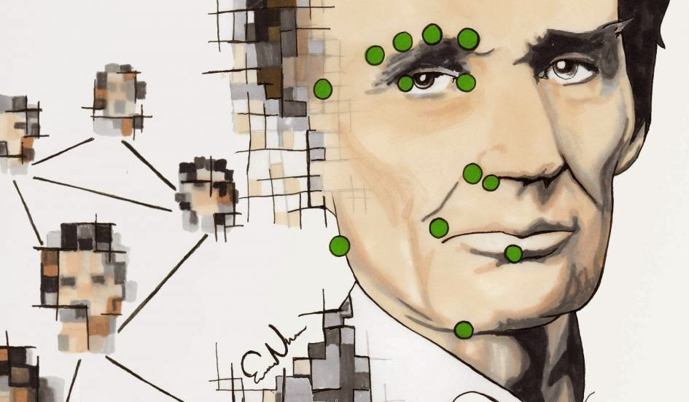
Family photo albums are dusty time capsules from another era. Butin the near future, they might also be crucial documents predicting future genetic diseases. Research led by Dr. Nellaker and Prof. Zisserman at the University of Oxford has have developed software that can detect the risk for genetic disorders in children, such as Down and Treacher Collins syndromes, just by scanning old photographs of their family members.
Over 7,000 rare genetic disorders are known, and although each is unique, there is at least one common thread: 30 to 40 percent of them involve detectable abnormalities in the cranium and face. The Oxford project, called Clinical Face Phenotype Space, builds on this knowledge, melding machine learning and computer technology to scan family photos and cross-reference them with a database built from images of people with known genetic disorders.
The Clinical Face Phenotype Space recognizes faces in photographs regardless of a person’s pose or facial expression, image quality, lighting variations or other factors. The project homes in on the person’s mouth corners, nose and eyes and compares them with photographs in the database to predict possible disorders. The photographs could be used to compare living children with photographs of their older relatives, even dead ones. Then the algorithm clusters people with similar conditions, potentially detecting disease long before it occurs. Researchers believe it could even help diagnose rare, previously undiagnosed disorders if patients are clustered with others who have previously undetected similarities.
For the trial run, researchers built a database with 1,515 healthy patients and 1,363 photographs depicting patients with eight known genetic disorders. The resulting algorithm correctly detected faces with disorders, making it 27 times easier to match with another face that had been shown to have the same disorder.
Today, 1 in 17 people has a genetic disorder, but only a minority of them receive an accurate clinical diagnosis due to unusual and varied symptoms among patients. Researchers hope that in the future physicians will be able to use a smartphone to take a photo of a patient and quickly run it through the database to discover if he or she has a genetic disorder. In the past, 3-D imaging has been used to analyze conditions like autism, schizophrenia and fetal alcohol syndrome, but this program takes complicated imaging equipment out of the equation altogether.

Family Photo Scans: The Future of Rare Disease Diagnosis

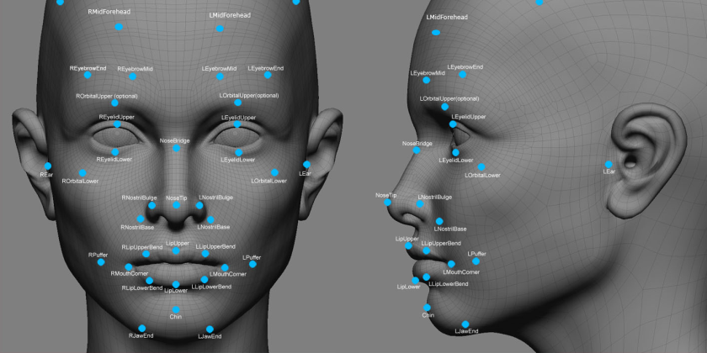

Scientists at Oxford University have developed a software that can detect the risk that a child has a genetic disorder by scanning family photos
Scientists at the University of Oxford have developed a revolutionary new software that can help diagnose someone’s risk of having a rare genetic disorder by scanning family photographs.
Most rare diseases have a genetic component, and interestingly, a significant proportion of rare genetic disorders (30 to 40 percent) are associated with facial structure abnormalities.
The researchers who created the software, Dr.Nellaker and Professor Zisserman, have named it the ‘Clinical Face Phenotype Space.’ The software works by scanning and analysing family photos and comparing them to a database of photos of individuals with known and diagnosed genetic disorders.
The software is unique in that is is able to analyse the facial features of an individual irregardless of the manner in which they are posing or other elements. This software could even compare the face of a child with the photographs of deceased relatives. This could help diagnose people who never suspected that they may have a rare disease, as they algorithm that the software is built on will cluster similar features into a group, and these can be compared.
Trials are already underway, and the scientists working on the project have built a database of 1,515 people to compare to 1,363 photo of people diagnosed with known genetic disorders. The results were encouraging, with the use of the software making the matching of the face of someone that had the same disorder 27 times more accurate.
This technology has significant implications for the field of medicine and diagnosis. The software could be designed as an app, allowing a doctor to simply take a photo of a patient to help them diagnose a rare condition.

